Sana’a
UNIVERSITY



FACULTY OF ENGINEERING

Mechatronics Department

Second Year

Report
How to Can Solve the Equation In(EES)

Supervision
Prof. Hamod Alnhary
Eng. Asm

Adopted by

Ibrahim Alkhlydy 202073007
Mechatronics (Parallel)

Table of Contents

Introduction............................................................................................................... ............. 1

Objecti........................................................................................................................................ 2

Methodology ...................................................................................................................... 3

Equipment........................................................................................................................... 4

Simulation and Results........................................................................................................................... 5

Obstacles ..................................................................................................... 6

References.............................................................................................................................................................. 7

Introduction:

The experience to learn how we can solve the equation and how find the another determines in the simulation of the application (EES) and from this application we also can draw carve and sketch of the value of the equation and make it as a table for know about the value of the equation and this application use it for find (the pressers, the valium, the temperature)

Objectives:

1) The objective of this experience how to determine the unknown of the equation if it is (Pressure, Valium , temperature)
2) How to know how to use the application
3) From this app how to cruet the equation

Methodology:

The methodology is the application how to know how to use it and you can solve the determine the unknown of the equation and draw the curves and sketch of the (Pursuers, Value, temperature)

- Simulation and Results:

Eq(1a)
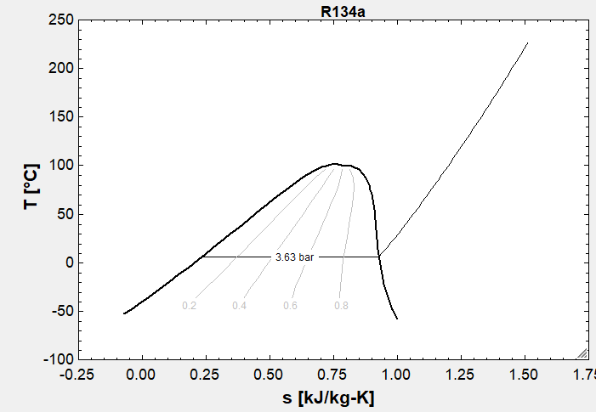

R-134a, T=60℃, V=0.072m^3/kg, Vg=0.014m^3/kg
Table A-12, P=3.63 bar, h=302.1 kJ/kg

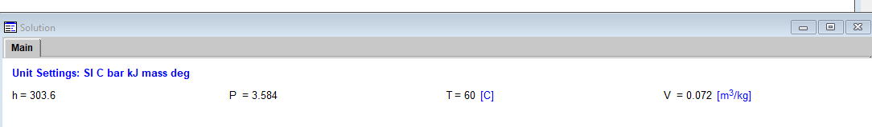
Eq(1b)
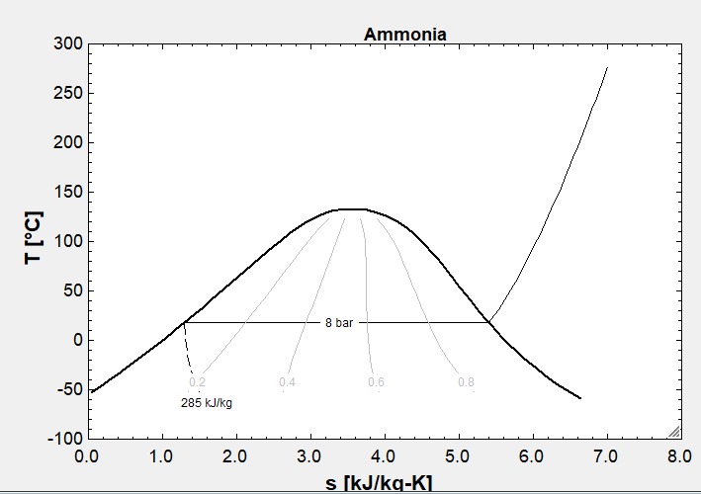

Ammonia, P=8 bar, V=0.005 m^2/kg, Vg=0.1596
T=Tsat=17.84℃ Table A-14
X=V-Vg/Vg-vf=
0.005-1.6302×10^-3/0.1596-1.630210×^-3=
0.02133
U=Uf+x(Ug-Uf)
262.64+(0.0213)(1330.64-262.64)=
285.4 kJ/kg

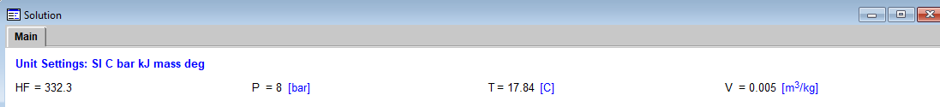

Eq(1c)
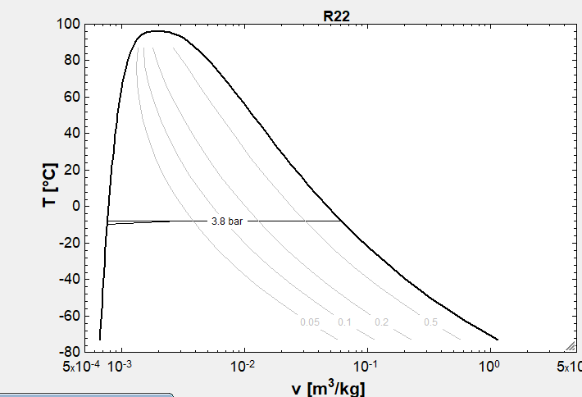
R-22, T=-10 ℃, U=200kJ/kg from Table A-7 at-10℃, uf<u<ug
P=Psat=3.8485 bar
X=u-uf/ug-uf=
200-33,7/223.02-33.26=0.899
V=℃f×(Vg-Vf)
0.760/10^3+0.87(0.0652-0.7606/10^3)=0.0574m^3/kg

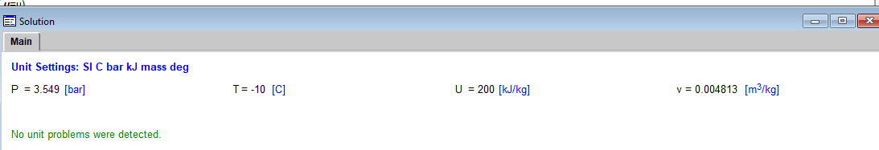

Eq(2a)
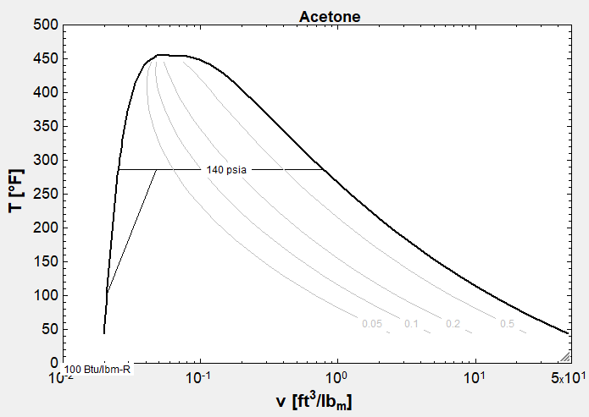
R-134a, P=140 ibf/in^2, h=100 Btw/ib From Table a-11E, hf<h<hg
X=h-hf/hfg=100-44.43/70.52=0.788
V=Vf=x(Vg-Vf)=0.138+(0.788)(0.3358-0.01386)=0.2675ft^3/ib
T=Tsat=100.56 F

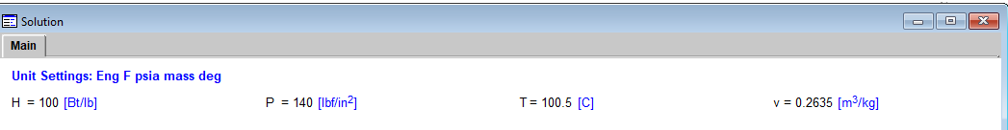

Eq(2b)
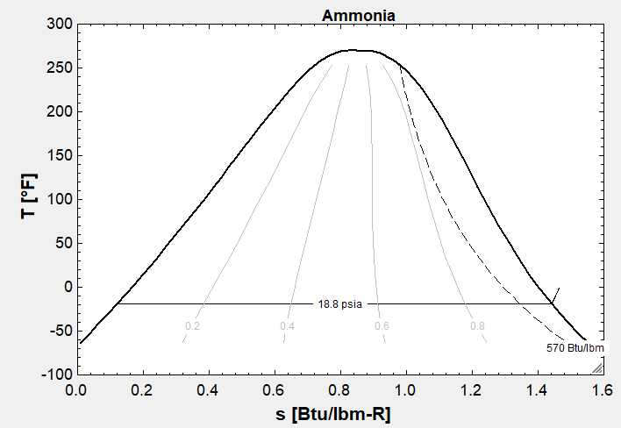
Ammonia, T=0 F, V=15 ft^3/ib from Table A-13E, Vg=9.1100 ft^3/ib V>Vg
From Table A-15E
P=18.85, h=615.2 Bkw/ib

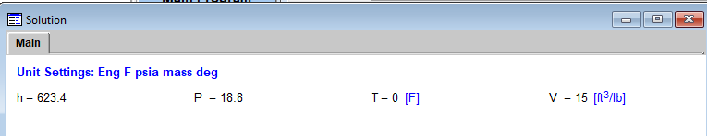

Eq(2c)
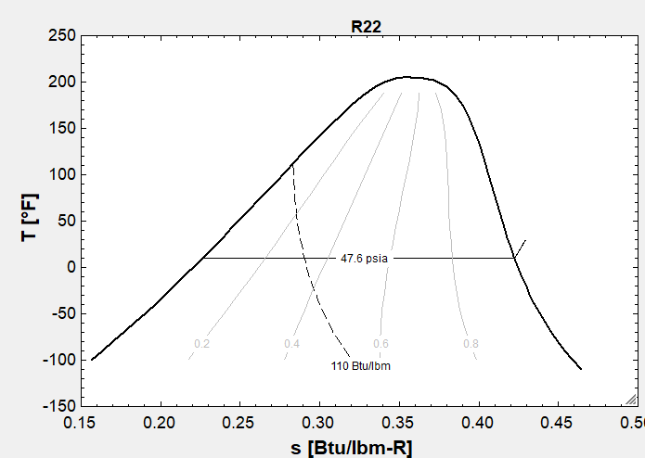
R-22, T=30 F, V=1.2 ft^3/ib from Table A-7E, Vg=0.7804ft^3/ib V>Vg
From Table A-9E
P=47.60 ibf/in^2
H=108.80 Bkw/ib

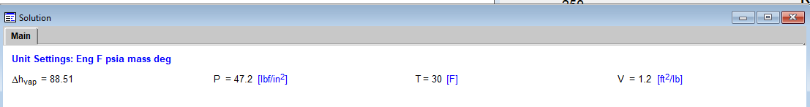

Q | P | V | T | H | U
1a | 3.36 bar | 0.072 m^3/hf | 60 c | 302.1 kJ/kg | --------
1b | 8 bar | 0.005 m^3/kg | 17.84 C | -------- | 285.4
1c | 3.8 bar | 0.057 m^3/kg | -10 C | -------- | 200 kj/kg
2a | 140Ibf/In^2 | 0.26 ft^3/Ib | 100.5 F | 100 Btu/Ib | ----------
2b | 18.85 Ibf/In^2 | 15 ft^3/Ib | 0 F | 615.2 Bty/Ib | -------
2c | 47.6 Ibf/In^2 | 1.3 ft^2/Ib | 30 F | 108.8 Btu/Ib | ----------

By (EES)

Q | P | V | T | H | U
1a | 3.3 bar | 0.072 m^3/kf | 60 C | 303 kJ/kg | --------
1b | 8 bar | 0.005 m^3/kg | 17.8 C | ----------- | 332.3kJ/kg
1c | 3.5 bar | 0.04 m^3/kg | -10 C | -------- | 200kJ/kg
2a | 140Ibf/In^2 | 0.263ft^3/Ib | 100.5 F | 100 btu/Ib | ----------
2b | 18.8Ibf/In^2 | 15 ft^3/Ib | 0 F | 623.4 Btu/Ib | --------
2c | 47.2Ibf/In^2 | 1.2 ft^2/Ib | 30 F | 88.51 But/Ib | ------------

Obstacles:
- The first obstacle is how to know about the application
And how to use it
- The second obstacle is how to use the unit of the value
- The difficult way to get the information about the application
- The biggest thing is the first time I use it
- In some unit I cannot know it and how to convert
- The last thing I cannot draw up to lain for the sketch

- References:
From YouTube and Google

